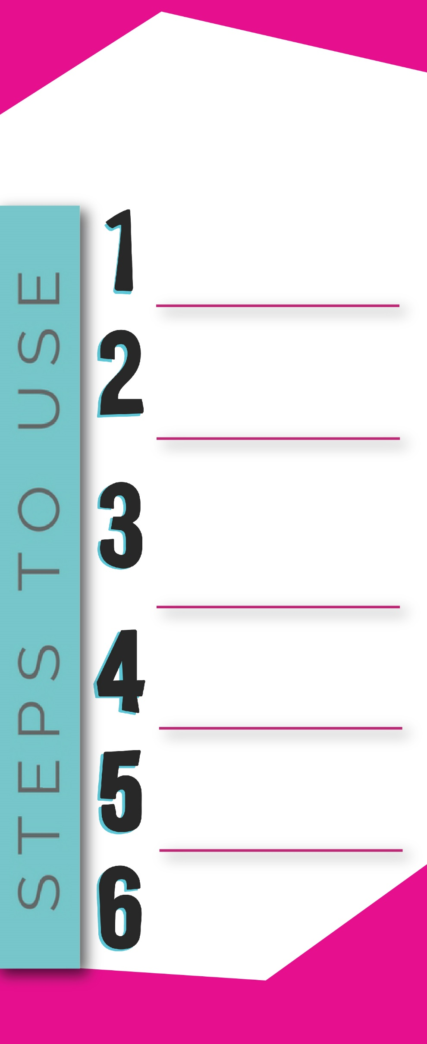

**SACRAMENTO REGION**

Follow the prompts to let your TMA know your contact info and the circumstantial info.

You will then be able to print a voucher that has the appropriate Yellow Cab or Enterprise phone number to call and schedule your ride.

**EMERGENCY RIDE HOME PROGRAM (ERH)**

To redeem an ERH voucher, click on **View All Rewards**. Find the ERH reward, click **Show Full Description**. Depending on the miles required to ride home, choose **Yellow Cab** or **Enterprise** Voucher. Click **Redeem Points** and follow the instructions.

Give the voucher to Yellow Cab or Enterprise and your trip will be paid for by your TMA.

Register to join on Sacregion511.org’s Platform (a commuter network for commuters that work at eligible companies) and set up a profile at **https://sacregion511.org/#/.**

**What is ERH?**

If you use transit, carpool, bike, vanpool or walk to work at least three times a week and experience a midday emergency, take a taxi or rental car home and receive a voucher for this expense.

To add your Network, click on your name in the top right-hand corner, click “Edit Profile” then “My Networks” on the left-hand side. Enter “Express Riders” in the box to add your network.

Go to your **Dashboard**. Input your to and from addresses, *log your daily commutes (HOME to WORK) and mode of travel in the **Dashboard** tab of Sacregion511.org.

Once finished, click **Log Trips**. You can log your trips daily or weekly.

**For complete program rules, visit “Incentives” tab at** [**https://sacregion511.org/#/pages/resource-page**](https://sacregion511.org/#/pages/resource-page)**.**

**Who can use this program?**

All commuters that work at Centene Sacramento Campus.

**How many times can I use ERH?**

You can use ERH up to six (6) times a calendar year.

**How much does it cost me?**

Sacregion511.org covers the ERH with a voucher.

**How do I qualify for an ERH?**

You must log your commute trips to qualify for the ERH rewards. As you continue to log your trips, your ERH reward points will increase. You can redeem those points as needed.

**What qualifies for an ERH?**

Personal or family illness or emergency, home emergency, elder care or day care emergency, bicycle theft or breakdown, unforeseen change of work schedule,   
inclement weather (for walkers/bicyclists), carpool partner emergency resulted in loss of ride home.

**Who can I contact for questions?**

General Questions: **mellissa@jibe.org**

*You can also use the Commute Tracker, Waze or Strava apps to log your trips under the Third Party Apps within your profile. All apps are available on the Google Play store.