**Getting started**:

Visit <http://www.sacregion511.org/> and it will take you to the Sacramento region Commuter club page.



Sign up for an account.



To add your network, go to your name in the top right-hand corner and click “EDIT PROFILE.” Then click “MY NETWORKS” on the left-hand column.

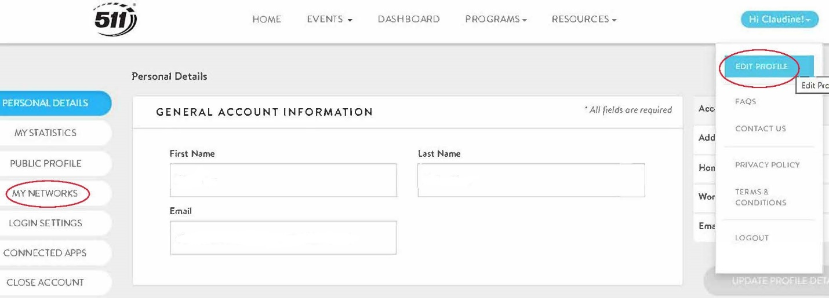

Add your network, Express Riders.

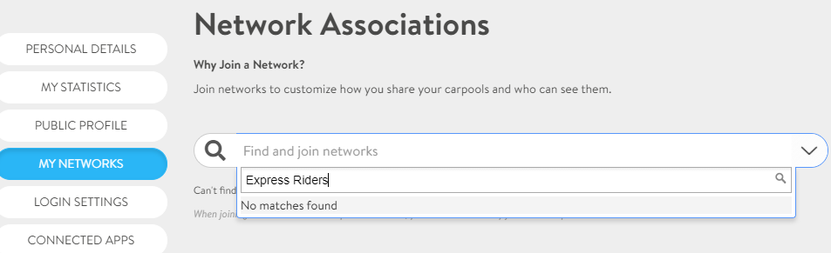

**Logging trips**:

Log daily trips on your Dashboard.



**Claiming Rewards**:

Once you have logged in your trips and completed the trip requirements for your selected travel mode (i.e., bike, public transit, walk, telework, carpool, etc.), “My Rewards” will show you in green which rewards you can claim.



Click on the highlighted green reward and click “CLAIM INCENTIVE.”



When you click the “Claim Incentive” tab, a notification will pop up stating your request was received.



JIBE will receive an email notification like this and contact you for further details.

